Traditional Memory – English
Sample front and back side of the cards:
apple | 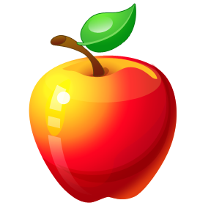
banana
tomato | 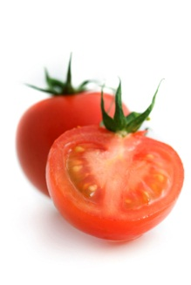
watermelon | 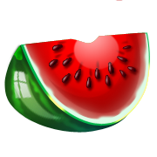
blueberry

